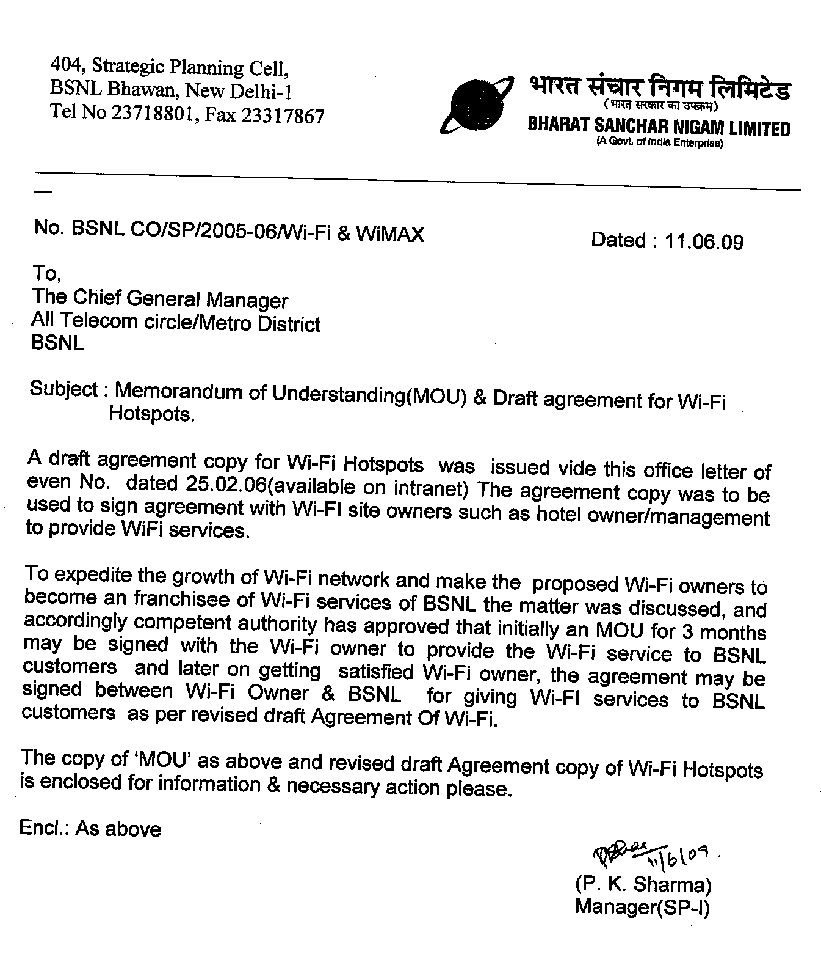

MEMORANDUM OF UNDERSTANDING

This Memorandum of Understanding is signed and entered into force on_________ by and between BSNL having its office at ______________________ and Wi-Fi owner having located at ______________ .

Objectives

To provide Broadband wireless connectivity to Wi-Fi site owner’s customers through Franchisee Agreement with BSNL.

Both the parties shall work together for setting up an in-building broadband internet and wireless hot spot at the WI-FI site for providing wireless broadband services through WiFi technology.

Business Model

BSNL shall provide prepaid coupons free of cost to the Wi-Fi owner. The Wi-Fi site owner may sell the recharge coupon to customer as per mutually agreed price(with BSNL). BSNL will be charging the WiFi owner on the usage of the prepaid coupons.

Obligation of Wi-Fi Owner : WiFi site owner shall provide space at its premises free of cost to BSNL& required cooperation to safeguard the BSNL equipment.

Obligation of BSNL : BSNL will set up the hardware software and cabling for provisioning of service

The ‘MOU’ between WiFi site owner & BSNL for provision of WiFi service shall be valid for 3 months. Both the parties on mutual agreeable basis may further continue to provide the service and make agreement in this regard in future.

IN WITNESS whereof this MOU has been duly signed by or on behalf of the parties hereto the day and year before written.

WIFI site Owner BSNL Officer

Witness Witness
- 1.
2. 2.

WI-FI SERVICE DELIVERY AGREEMENT

This agreement (hereinafter ‘Agreement’) is being made at on this the day of 2009 (the "Effective Date") between

Bharat Sanchar Nigam Ltd., Between Bharat Sanchar Nigam Ltd, a company having its registered office at Bharat Sanchar Bhawan, H. C. Mathur Lane, Janpath, New Delhi – 110 001 (hereinafter referred to as “BSNL”), which expression, unless repugnant to the context or meaning hereof, shall include its successors, administrators or permitted assignees; having in Telecom circle office at _____ and at present represented by their CGM or his representative.

AND

XYZ . a company incorporated under the provisions of the Companies Act, 1956 and having its registered office at ………………., India, (hereinafter referred to as “Wi-Fi site owner” which expression unless repugnant to the context and meaning thereof shall mean and include its successors and assigns) and at present presented by their Chairman & Managing Director or his representative
BSNL,WI-Fi site owner are hereinafter individually referred to as party and collectively as parties.

WHEREAS Wi-Fi site owner is running a Hotel/Restaurant by the name of …… located at ……. hereinafter referred to as the “Wi-Fi site ”

AND WHEREAS BSNL is also in the business of providing telecom services, broadband internet and wireless hot spot solutions and support and value added services

AND WHEREAS both parties wish to work together for setting up an in-building broadband internet and wireless hot spot at the WI-FI SITE for providing Wireless broadband services through Wi-Fi technology.

NOW THIS AGREEMENT WITNESSETH AS FOLLOWS:
- In consideration of the due observance and performance of all the terms and conditions mentioned in this WI-FI Service delivery Agreement and the Schedules and Annexures attached hereto,forming part and parcel of this agreement. BSNL and M/s. ‘WI-FI SITE OWNER’ agree to sign this WI-FI Service delivery Agreement to provide Broadband wireless internet connectivity to Wi-Fi site owners’ customers as per terms & conditions contained in various Schedules and Annexures attached hereto.
- This WI-FI Service delivery Agreement shall remain in force initially for a period of three years from the date of execution unless revoked earlier for whatever reasons. BSNL may extend, if deemed expedient, the period of agreement by one year at one time or as may be agreed between the parties, suo-moto or upon request of M/s. ‘WI-FI SITE OWNER’, if made at least six months before expiry of currency of the agreement, on mutually agreed terms. The decision of BSNL shall be final in regard to the grant of extension.
- Breakdown Maintenance

BSNL will respond to the breakdown either by:
i) Rectifying the problem over the phone;
ii) Visiting the Hot Spot where these measures do not diagnose or clear the fault and where it is considered necessary. Without undue delay BSNLwill take all proper steps to correct the fault in the Service.

- The applicable laws and such rules and regulations of India or Rules/Regulation/Directions or Regulator or appropriate access as promulgated/modified/amended or replaced from time to time shall govern this Agreement. This WI-FI Service delivery Agreement shall be subject to jurisdiction of the courts at the HQs of Telecom circle of BSNL.

5. Title of Goods:

BSNL shall hold all legal rights and title to all products including hardware, software and cabling installed at the Wi-Fi site .
Wi-Fi site owner will hold all legal rights and title to the cabling arranged by the Wi-Fi site owner.

6. Non-Disclosure:

Both parties agree that any information that either party may receive in the process of providing services under this Agreement is confidential in nature and the same shall not be disseminated or used in any manner whatsoever in a manner other than that provided in the Agreement.

Both parties may divulge such Confidential Information only to such of their employees, as must have access to it in order to provide services mentioned under Agreement; all other persons shall be deemed “unauthorized” for purpose of Agreement.

IN WITNESS whereof this Agreement has been duly signed by or on behalf of the parties hereto the day and year before written.

Director Chairman & Managing Director
XYZ BSNL

Witnesses Witnesses

1). ____________________ 1). ____________________

2). ____________________ 2). ____________________

SCHEDULE I - SCOPE OF AGREEMENT

- Purpose of Agreement
The purpose of this Agreement is to enable BSNL to enter into a non-exclusive agreement with Wi-Fi site owners to provide Wi-Fi services to the customers of Wi-Fi site owners. Wi-Fi is a technology to provide wireless internet connectivity to customers having the required equipment.
- Business Model
    - BSNL hereby authorises ‘Wi-Fi site owner’ to charge its customers on a mutually agreed price. The prepaid coupons will be provided by BSNL free of cost to the Wi-Fi site owners. BSNL will be charging the WI-FI site owner on the usage of different prepaid coupons as in Annexure-I. The Wi-Fi site owner can have its own markup and sell the recharge coupons at a higher price and the final price will be displayed on the coupon.

3. Obligations of Wi-Fi site owner :

  - Wi-Fi site owner will provide all required cooperation and space at its premises, free of cost to BSNL for setting up the hardware, software and cabling for provisioning the service.
  - The Broadband wireless internet connectivity will be provided to the customers of Wi-Fi site owners.The customers of Wi-Fi site owners will be the user of Wi-Fi service. Here the customers are those who are availing the services, like boarding and lodging, provided by Wi-Fi site owners at a price.Wi-Fi site owner will do its utmost to promote the service in the Wi-Fi site through providing tent cards in rooms and other Wi-Fi sites and suitable posters in public areas. Such tent cards etc. will carry the name of BSNL and the Wi-Fi site owner. The cost of such tent cards/posters will be to the account of the Wi-Fi site owner.
  - Wi-Fi site owner at his own cost will provide adequate table and storage space in the Wi-Fi site for BSNL staff to carry out the services and to store spare parts and documentation.
  - The Wi-Fi site owner will be responsible for the safe custody of BSNL equipment at the Wi-Fi site. However BSNL will insure the equipment installed by it to cover loss due to theft and damage.
  - The Wi-Fi site owner will take adequate precautions such that BSNL wireless cards loaned to users by Wi-Fi site owner staff are taken back.
  - The Wi-Fi site owner will have to pay to BSNL the billed amount on the usage of Wi-Fi service.

4. Areas of Operation
The area of operation for the Wi-Fi hotspot is which is legally under possession by the Wi-Fi site owner and which lies in the range of Wi-Fi equipment radio signal.

SCHEDULE II – GENERAL TERMS & CONDITIONS

- Modifications In The Terms And Conditions Of Agreement
  - The terms and conditions of the Agreement are subject to modification by mutual agreement based upon the request of either party.

- Exclusivity
  - M/s. ‘WI-FI SITE OWNER’ shall provide the services as provided in this agreement exclusively through BSNL and not through any other licensed telecom service provider in the same service area during the tenure of the Agreement. However BSNL has right to sign agreement with different site owners.
- Suspension, Revocation or Termination of Agreement
  - Suspension of Agreement
    - BSNL reserves the right to suspend the operation of this agreement, at any time, due to change in its own license conditions or upon directions from the DOT/ Government of India.
    - In such a situation, BSNL shall not be responsible for any damage or loss caused or arisen out of aforesaid action.
    - Further, the suspension of the agreement will not be a cause or ground for extension of the period of the agreement and suspension period will be taken as period spent. During this period, no charges for use of the facility of M/s. ‘WI-FI SITE OWNER’ shall be payable by BSNL.
- Termination of Agreement
    - BSNL may, without prejudice to any other remedy available for the breach of any conditions of agreement, by a written notice of two months issued to M/s. ‘WI-FI SITE OWNER’ at its registered office, terminate this agreement wholly or for selected Telecom Circles in the Area of Operation under any of the following circumstances:
- M/s. ‘WI-FI SITE OWNER’ failing to perform any obligation(s) under the agreement;
- M/s. ‘WI-FI SITE OWNER’ failing to rectify, within the time prescribed, any defect as may be pointed out by BSNL;
- M/s. ‘WI-FI SITE OWNER’ going into liquidation or ordered to be wound up by competent authority.
    - If M/s. ‘WI-FI SITE OWNER’ wounds up or goes into liquidation, it shall immediately (and not more than a week) inform about occurrence of such event to BSNL in writing. In that case, the written notice period for termination can be modified by BSNL as deemed fit under the circumstances. BSNL may either decide to issue a termination notice or to continue the agreement by suitably modifying the conditions, as it feels fit under the circumstances.
    - Breach of non-fulfilment of Agreement conditions may come to the notice of BSNL through complaints or as a result of the regular monitoring. Wherever considered appropriate, BSNL may conduct an inquiry either suo-moto or on complaint to determine whether there has been any breach in compliance of the terms and conditions of the agreement by M/s. ‘WI-FI SITE OWNER’ or not. M/s. ‘WI-FI SITE OWNER’ shall extend all reasonable facilities and shall endeavour to remove the hindrance of every type upon such inquiry.
    - BSNL reserves the right to terminate this agreement any time if after signing the agreement, it comes to the notice that agreement has been signed based upon false/incorrect information.

  - Exit Clause
    - Either party may terminate the agreement unconditionally after a minimum period of twelve months from the date of signing of this Agreement, by giving notice of at least three months in advance. The effective date of surrender of agreement will be three months counted from the date of receipt of such notice by the other party to the authority that signed the agreement on behalf of other party.

- Actions pursuant to Termination of Agreement
  - Notwithstanding any other rights and remedies provided elsewhere in the agreement, upon termination of this agreement:
    - Neither Party shall represent the Other Party in any of its dealings.
    - Neither Party shall intentionally nor otherwise commit any act(s) as would make a third party to believe that the other Party is still the former Party’s M/s. ‘WI-FI SITE OWNER’/ Network provider, as the case may be.
    - Each party shall stop using the other Party’s name, trade mark, etc., in any audio, visual or print form.
    - The expiration or termination of the Agreement for any reason whatsoever shall not effect any obligation of either Party having accrued under the Agreement prior to the expiration of termination of the Agreement and such expiration or termination shall be without prejudice to any liabilities of either Party to the other Party existing at the date of expiration or termination of the Agreement.
    - After expiration or termination of agreement, as the case may be,all equipment installed by BSNL at Wi-Fi site will be removed by BSNL and outstanding dues if any shall be paid by the Wi-Fi site owner(s) to BSNL immediately on termination/expiration of the agreement. Further Wi-Fi site owner(s) agrees that he/they will not cause any hindrance of whatsoever nature in removing the said equipment by BSNL’s employees/agents and in this regard it shall fully cooperate with BSNL.

- Dispute Settlement
  - Any dispute or differences which may hereinafter arise between the Parties hereto in connection with this Agreement or in connection with the interpretation or breach & violation relating to any of the terms and conditions herein contained and/or in connection or anyway relating to the rights & obligations of the parties hereto under this Agreement, shall be referred to the sole Arbitration of the General Manager Telecom District(GMTD)/PGM TD of respective area of BSNL or any other person appointed ny name or in case of designation of GMTD/PGM TD is changed or their o/o is abolished then in such cases to the officer in the time being entrustee whether in addition to his own office with the functions of GMTD or whatever designations of such officer may be called. In the event of such Arbitrator to whom the matter is originally referred to is being transferred or vacates his office on resignation or other wise or refuses to do work or neglecting his work or being unable to act as Arbitrator for any reasons whatsoever, GMTD BSNLshall appoint another person to act as Arbitrator in place of out going Arbitrator and the person so appointed shall be entitled to proceed further with the reference from the stage at which it was left by his predecessor. The M/s. ‘WI-FI SITE OWNER’will have No Objection in any such appointment, that arbitrator so appointed by BSNL is an employee of BSNL. The said Arbitrator shall act under the Provisions of the Arbitration and Conciliation Act, 1996 or any statutory modifications or reenactment there of. The venue for all such arbitration proceedings shall be New Delhi, India or some other palce as the Arbitrator may decide.

- Force- Majeure
  - If at any time, during the continuance of this agreement, the performance in whole or in part, by either party, of any obligation under this agreement is prevented or delayed, by reason of war, or hostility, acts of the public enemy, civic commotion, sabotage, Act of State or direction from Statutory Authority, explosion, epidemic, quarantine restriction, strikes and lockouts (as are not limited to the establishments and facilities of BSNL and M/s. ‘WI-FI SITE OWNER’), fire, floods, natural calamities or any act of God (hereinafter referred to as event), provided notice of happenings of any such event is given by the affected party to the other, within 21 Calendar days from the date of occurrence thereof, neither party shall, by reason of such event, be entitled to terminate the agreement, nor shall either party have any such claims for damages against the other, in respect of such non-performance or delay in performance.
  - Provided Service under the agreement shall be resumed as soon as practicable, after such event comes to an end or ceases to exist. The decision of BSNL as to whether the service may be so resumed (and the time frame within which the service may be resumed) or not, shall be final and conclusive.
  - However, the Force Majeure events noted above will not in any way cause extension in the period of the agreement.

- Right to Inspect
  - M/s. ‘WI-FI SITE OWNER’ will provide the necessary facilities for continuous monitoring of the system, at its own cost when required by BSNL or the licensor (DOT) or the regulator (TRAI) or any law enforcement agency empowered to do so. The inspection will ordinarily be carried out after reasonable notice except in circumstances where giving such a notice will defeat the very purpose of the inspection.
  - Wherever considered appropriate BSNL may conduct any inquiry either suo-moto or on receipt of complaint to determine whether there has been any breach in compliance of terms & conditions of the agreement by M/s. ‘WI-FI SITE OWNER’ or not. In case of such inquiry, M/s. ‘WI-FI SITE OWNER’ shall extend all reasonable facilities without any hindrance.
- Confidentiality of Information
  - Subject to conditions contained in this Agreement, M/s. ‘WI-FI SITE OWNER’ shall take all necessary steps to safeguard the privacy and confidentiality of any information about BSNL and/or WI-FI site owner’s customers from whom it has acquired such information by virtue of the Service provided and shall use its best endeavours to secure that:
    - No person acting on behalf of M/s. ‘WI-FI SITE OWNER’ or M/s. ‘WI-FI SITE OWNER’ himself divulges or uses any such information except as may be necessary in the course of providing Services to BSNL’s Subscriber; and
    - No person seeks such information other than is necessary for the purpose of providing Services to BSNL’s Subscriber.
Provided, the above para shall not apply where BSNL has consented in writing to such information being divulged or used and such information is divulged or used in accordance with the terms of that consent; or the information is already open to the public

- Set- off:
  - Any sum of money due and payable to BSNL under this Agreement or otherwise shall be appropriated by WI-FI SITE OWNERunder intimation to BSNL and the same may be set off against any claim of BSNL for payment of a sum of money arising out of this Agreement or under any other Agreement made by M/s. ‘WI-FI SITE OWNER’with BSNL.

- Indemnification:
  - M/s. ‘WI-FI SITE OWNER’agrees to protect, defend, indemnify and hold harmless BSNL and its employees, officers, directors, agents or representatives from and against any and all liabilities, damages, fines, penalties and costs (including legal costs and disbursements) arising from or relating to:
    - Any breach of any statute, regulation, direction, orders or standards from any governmental body, agency, telecommunications operator or regulator applicable to such party;
    - Any breach of the terms and conditions of this agreement by M/s. ‘WI-FI SITE OWNER’;
    - Any claim arising out of recoveries or any other reason from Banks/ Financial Institutions / third parties.
    - Any claim of any infringement of any intellectual property right or any other right of any third party or of law by M/s. ‘WI-FI SITE OWNER’;
    - Any claim made by any third party arising out of the use of the services and arising in connection with degradations of services as defined in the Quality of Service (QoS) to BSNL’s customers caused solely by M/s. ‘WI-FI SITE OWNER’.
  - This clause shall survive the termination or expiry of this Agreement.

- Relationship
  - Each party understands that it is an independently owned business entity and this Agreement does not make it, its employees, M/s. ‘WI-FI SITE OWNER’s or agents as employees, agents or legal representatives of the other party for any purpose whatsoever. Nothing contained in this Agreement will be deemed to form a Parnership, agency or Joint venture between the Parties.
  - Neither party has express or implied right or authority to assume or to undertake any obligation in respect of or on behalf of or in the name of the Other Party or to bind the Other Party in any manner.

- Liability
  - Except as provided in this Agreement, hereinabove, neither party shall be liable to other party or any other party by virtue of termination of this Agreement for any reason whatsoever for any claim for loss or profit or on account for any expenditure, investment, leases, capital improvements or any other commitments made by the other party in connection with their business made in reliance upon or by virtue of this Agreement.

- Notices
  - All notices, communications and other correspondence required or permitted by this WI-FI Service delivery Agreement shall be in writing and shall be sent by
    - facsimile, with confirmation copy sent by registered mail,
    - by personal delivery with acknowledgement of receipt or
    - by registered mail, return receipt requested and postage prepaid
  - There shall be a Nodal Officer of BSNL in each Circle, who shall be General Manger (Business Development) /GMTD or any other Officer nominated by the concerned CGM of the Circle for the purpose and shall be responsible for monitoring of services to be provided and settlement of accounts as per terms and conditions under this agreement.

  - All communication to BSNL shall be addressed to the PGMTD/GMTD of concerned Telecom Circle of operation & or a copy to BSNL Corporate Office at the following address:
GM (BD)
Bharat Sanchar Nigam Ltd.
Room No. 413
Bharat Sancher Bhawan
H. C. Mathur Lane, Janpath

New Delhi – 110001, India

Phone No : 011-23734010

Fax Number: 011-23734012 .

  - The communication to M/s. ‘WI-FI SITE OWNER’ shall be addressed to its Corporate office:
Kind Attn: Shri. XYZ
M/s. WI-FI SITE OWNER .,

Phone No.:

SCHEDULE II - FINANCIAL TERMS & CONDITIONS
Tariffs and charges payable by users and schemes to be offered to users will be decided by mutual consultation between BSNL and Wi-Fi site owner. BSNL will be charging the WI-FI site owner on the usage of different prepaid coupons as in Annexure-I. The Wi-Fi site owner can have its own markup and sell the recharge coupons at a higher price and the final price will be displayed on the coupon. In case of prepaid cards,as soon as the user logs in to avail the service,full value of BSNL’s share of card price will be charged to the Wi-Fi site owner irrespective of partial or full utilization.The Wi-Fi site owner shall pay to BSNL as per Annex I on usage of different prepaid coupons issued by BSNL to Wi-Fi site owners.
BSNL will issue the prepaid coupons to the Wi-Fi site owners free of cost. The cards will have a validity period and the unused cards will be returned back to BSNL after the expiry of validity period.
The Wi-Fi site owner will be billed fortnightly. The Wi-Fi site owners shall pay the billed amount within 15 days of the issue date of the bill. The payment can be made in cheque in favour of BSNL at any collection centre. If the payment is delayed a surcharge of 4 percent will be charged.

ANNEXURE I – APPLICABLE TARIFFS FOR Wi-FI SITE OWNERS
Usage charges
Rental per access point

ANNEXURE II – DEFINITIONS

Unless the context otherwise requires, the different terms and expression used shall have the meaning assigned to them in the following paragraph:

- BSNL means Bharat Sanchar Nigam Limited.
- WI-FI- Wireless Fidelity
- Access Point is the Wi-Fi equipment which radiates radio waves. This radio wave is received by the device of users.
- PCM-CIA card is used by users for Wi-Fi connectivity. This card is inserted in the computer of user in appropriate slots.
- Tent card: is a card having a triangular crosssection resting on a table. The instruction to use Wi-Fi service is written on this tent card.
- Customer: Here customer is the person who uses the primary services such as boarding or lodging offered by the Wi-Fi site owner at a price.
- User is the person who uses Wi-Fi service.
- Tariff means Charges payable by the subscriber for the service provided.
- Telecom Circle/Circle means the geographical area of the BSNL circle providing the Basic Telecommunication Services as defined by BSNL.
- TRAI means Telecom Regulatory Authority of India established under the TRAI Act, 1997.
- Premises means the area which is legally under possession by the Wi-Fi site owner and which lies in the range of Wi-Fi equipment radio signal.
- Hot Spot is the physical space around accesspoints, in which the Wi-Fi signals are available for usage.
- Wi-Fi site is the location of hotspot. The access points are put in the Wi-Fi site.

